Building on Ubuntu20.04.6

1. Copy files in the var-lib-apt-lists folder into /var/lib/apt/lists folder

If you had already installed other offline packages such as gr-osmosdr, copy only 3 files

ppa.launchpad.net_nuandllc_bladerf_ubuntu_dists_focal_InRelease

ppa.launchpad.net_nuandllc_bladerf_ubuntu_dists_focal_main_binary-amd64_Packages

ppa.launchpad.net_nuandllc_bladerf_ubuntu_dists_focal_main_i18n_Translation-en

1. sudo sh -c 'echo "deb http://ppa.launchpad.net/nuandllc/bladerf/ubuntu $(lsb_release -sc) main" > /etc/apt/sources.list.d/nuandllc-ubuntu-bladerf-focal.list'
2. Install synaptic

cd synaptic

sudo dpkg -i libept1.6.0_1.1+nmu3ubuntu3_amd64.deb

sudo dpkg -i libxapian30_1.4.14-2_amd64.deb

sudo dpkg -i synaptic_0.84.6ubuntu5_amd64.deb

OR

sudo dpkg –I *.deb

1. Extract gnuradio_3.8.1.0~rc1-2build2_amd64.zip file in the var-cache-apt-archives directory to the same folder
2. Install packages by using synaptic

1) Open synaptic

sudo synaptic

2) open Menu -> File -> Add download packages

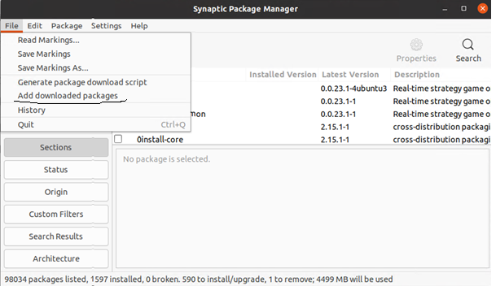

3) In the dialogbox, select var-cache-apt-archives folder

4) Click Apply button

1. Build and install BladeRF by using cmake
2. BladeRF is source folder
3. Refer the section 7. Getting Started: Linux in the bladeRF wiki.docx

**** **We are no loger recommending** [PyBOMBS](https://github.com/gnuradio/pybombs" \l "pybombs) **to install modern versions of GNU Radio.**

